1. 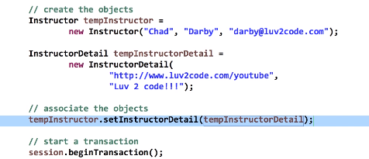  
   see in both tables, entries were made. 